Supplementary Material: Security optical interconnects using orbital angular momentum (OAM) beams multiplexing/multicasting

Yifan Zhaoa,b,c, Jun Liua,b,c, Shuhui Lia,b,c, Andong Wanga,b,c, Long Zhua,b,c, Yan Luoa,b,c, Shi Chena,b,c, Nan Zhoua,b,c, Shuang Zhenga,b,c, Jing Dua,b,c,*, Jian Wanga,b,c,*

a Huazhong University of Science and Technology, Wuhan National Laboratory for Optoelectronics and School of Optical and Electronic Information, Wuhan, Hubei, China, 430074

b Optics Valley Laboratory, Wuhan, Hubei, China, 430074

c Shenzhen Institute of Huazhong University of Science and Technology, Shenzhen 518000, China.

**\***Fourth Author**,** E-mail: [jing_du@hust.edu.cn](mailto:jing_du@hust.edu.cn), [jwang@hust.edu.cn](mailto:jwang@hust.edu.cn)

# 1 Signal modulation and demodulation

The diagram of transmitter is shown in Fig. S1(a). The 16-QAM signal is generated utlizing an arbitrary waveform generator (Tektronix AWG 70002) operated at 10 Gbaud to drive an in-phase/quadrature (I-Q) modulator. Both lasers at the transmitter and local oscillator (LO) laser at the receiver have a linewidth of 1 kHz. At the receiver, the demultiplexed signals is pre-amplified using an erbium-doped fiber amplifier (EDFA) with a fixed gain and sent to a coherent receiver, as shown in Fig. S1(b). Subsequently, this amplified light is sent to a variable optical attenuator (VOA) followed by an EDFA operating in fixed power output mode, with optical signal-to-noise ratio (OSNR) control achieved by adjusting the attenuation level of the VOA. The received waveforms are sampled and stored using a real-time sampling oscilloscope (Keysight DSA-Z 204A) operating at 80 GS/s with a bandwidth of 20 GHz. The offline digital signal processing used to recover the transmitted signal is as follows. The received signals were firstly re-sampled to two samples per symbol. Secondly, a 13-tap, T/2-spaced adaptive finite impulse response (FIR) filter, based on the cascaded three-modulus algorithm, is utilized for channel equalization. After equalization, the FFT-based frequency offset estimation and phase estimation are employed for carrier synchronization and phase tracking. Finally, the recovered constellation is demapped to obtain the bit sequence which are compared to the sent bit sequence and used for bit-error counting. During practical experimental testing of BER-OSNR curves, the beam may fluctuate over time, resulting in a temporal variation of OSNR. To record BER values near a specific OSNR value, we initially set the attenuation of the VOA to vary the OSNR around a certain value. Then, we record multiple sets of BER values, identify the BER corresponding to the specific OSNR value in each set, and take the average to obtain the desired final BER value.

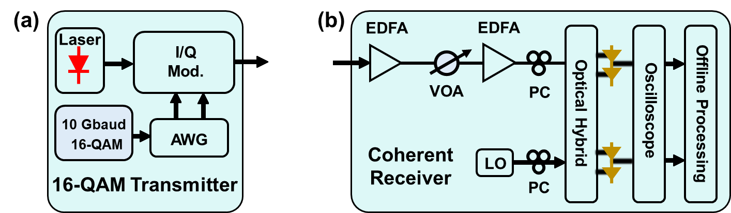

Fig. S1 Signal modulation and demodulation. (a) Schematic of 10 Gbaud 16-QAM transmitter. AWG, arbitrary waveform generator; I/O mod., in-phase/quadrature modulator. (b) Coherent receiver for off-line digital signal processing. EDFA, erbium-doped fiber amplifier; VOA, variable optical attenuator; PC, polarization controller; LO, local oscillator.

# 2 Practical pictures for experimental setup

The practical pictures of the experimental setup for 260-meter security OAM-multiplexed/multicasted link is shown in Fig. S2.

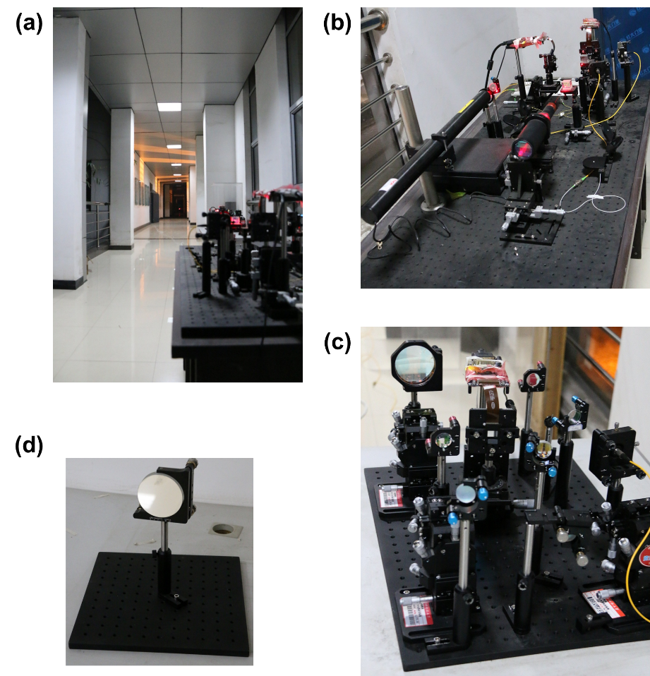

Fig. S2 (a) The layout between corridors which is exposed to the atmospheric conditions from WNLO-E to WNLO-H. (b) Site#1: Orbital angular momentum multiplexing/multicasting transmitter at the front of WNLO-E. (c) Site#2: Receiver at the front of WNLO-E. (d) Site#3: Reflection at the gate of WNLO-H where is 130-m away from Site#1 and Site#2. WNLO: Wuhan National Laboratory for Optoelectronics.

# 3 Intensity profiles and interferograms

The intensity profiles covering topological charge from $l=-6$ to $l=+6$ excluding Gaussian beam are presented in Fig. S3(a) and Fig. S3(b) (left part). Noted that the contrast ratio of each intensity profile doesn’t represent its practical intensity. In fact, as the topological charge increase, the power of the OAM mode decreases especially for after 260-m propagation and we adjust the input power and camera exposed time to make each profile have same contrast ratio. The superposition for every two inverse topological charges remains a whole ring because they are decorrelated by a delay in one channel. The right part for both Fig. S3(a) and Fig. 3S(b) illustrated the interferograms with Gaussian beam. It can be seen that clockwise-direction for plus topological charges and anticlockwise-direction for minus ones and there are $x$ petals for $\left|l\right|=x$.

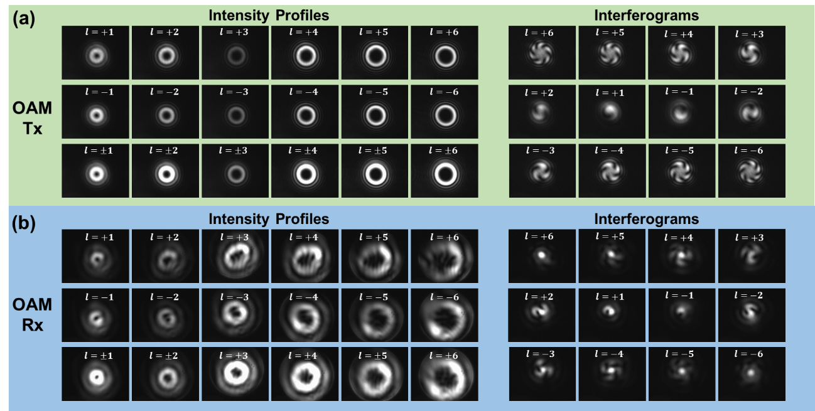

Fig. S3 OAM intensity profiles and interferograms at (a) transmitter side and (b) at receiver side from $l=-6$ to $l=+6$ excluding Gaussian beam.

# 4 Off-line feedback process

In our previous works, we presented a pattern search assisted iterative (PSI) algorithm to simultaneously generate multiple OAM modes using a single phase-only SLM38. It is also proved that we can achieve high diffraction efficiency (>93%) and low relative root-mean-square error (R-RMSE) even generate more than 50 evenly spaced OAM modes. What’s more, we demonstrated an adaptive power-controllable OAM multicasting experiment by introducing off-line feedback process in the labs at the range of few meters.39 Here we demonstrate a further experiment for 260-m 1-to-9 OAM multicasting optical interconnects link employing such complex pattern from38 and off-line feedback process like39 to achieve power-controllable application.

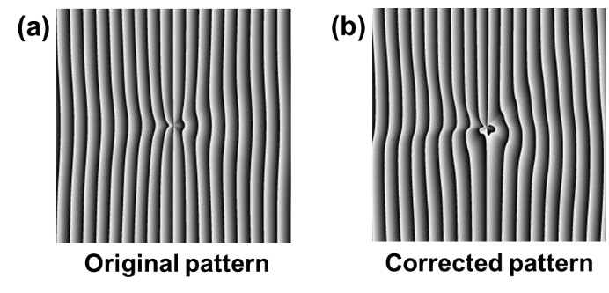

Fig. S4 (a) Original pattern for 1-to-9 multicasting with designed same power distribution. (b) Corrected pattern for 1-to-9 multicasting with practical same power distribution.

Figure S4(a) presents the original pattern for 1-to-9 OAM multicasting and the designed power distribution is same for all 9 multicasting channels as shown in Fig. 6(a1). However, after 260-m propagation, the power distribution is disturb resulting from the atmospheric turbulence and other reasons such as slight displacement at the receiver side (Fig. 6(a1)). For correct this disturbance, we firstly get the back-converted power of each multicasting OAM channel and compute the power difference between the target value and measured power. According to the computed results, we adjust weight coefficients in the PSI algorithm to achieve new optimized complex multicasting phase pattern. Repeat the similar feedback process until the measured power distribution is equal to the target one as shown in Fig. S4(b).

# 5 The intensity profiles of OAM Multicasting

With original pattern for designed power-equally OAM multicasting, Fig. S5(a) displays the intensity profiles in Tx and Rx after 260-m propagation. The demodulated intensity profiles are also presented loading different demodulation pattern from $l=-6$ to $l=+6$. It is obvious that there is a hot spot in the center of the profiles (emphasized by a white dash circle) when demodulated from $l=-4$ to $l=+4$ leading large coupled efficiency to SMF. However, for loading $l=±5$ to $l=±6$ on SLM-3, the center of profiles is empty resulting low coupled efficiency to SMF. Similarly, the intensity profiles after off-line feedback process are illustrated in Fig. S5(b) with a complex corrected pattern.

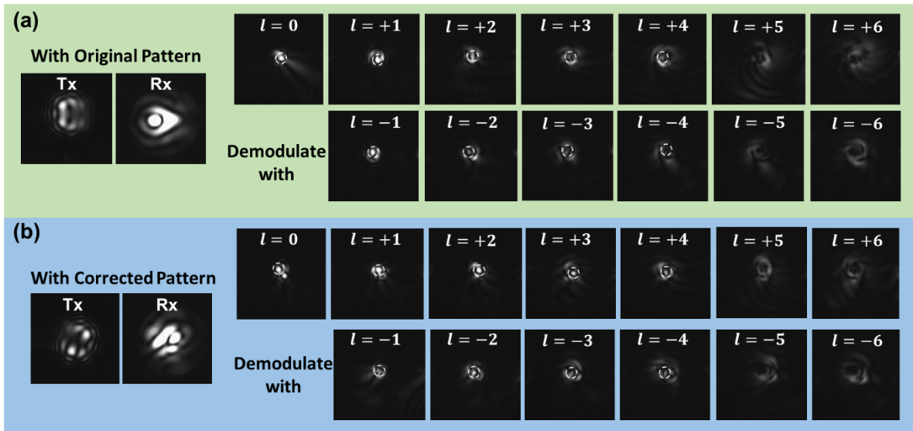

Fig. S5 The intensity profiles of 1-to-9 multicasting at Tx and after 260-m propagation at Rx with (a) original pattern and (b) corrected pattern respectively and their demodulated profiles with different topological charges.

# 6 Beam divergence controlling

For long distance propagation, higher-order OAM beams diverge faster than the lower orders. So that it is necessary to control the beam divergence because there is little power in the center of OAM modes which will lead information loss. As is reported in Ref. 44, the beam divergence can be controlled effectively by means of adjusting the lenses spacing shift $∆$ is defined as $d-f_{1}-f_{2}$, with $d$ representing the spacing between lenses. Here we adopt a 1:20 expander (Thorlabs, GBE20-C) which is fine designed for magnifying and collimating the light beam. What’s more, there is an adjustment for changing the spacing shift $∆$ to control the beam divergence.

# 7 Beam displacement

We record the beam displacement after beam reduction for topological charge of $l=-3$ (See Fig. S6). After demodulating, we record 200 intensity profiles at the interval of 1 second for both $l=+3$ and $l=-3$ respectively (See Fig. S7 and Fig. S8) and then recovery the physical position fluctuations according pixel’s size from the camera. We pick up the center hot spots’ position in demodulation profiles and the statistic results fluctuations is shown in Fig. 3(a1) and (a2).

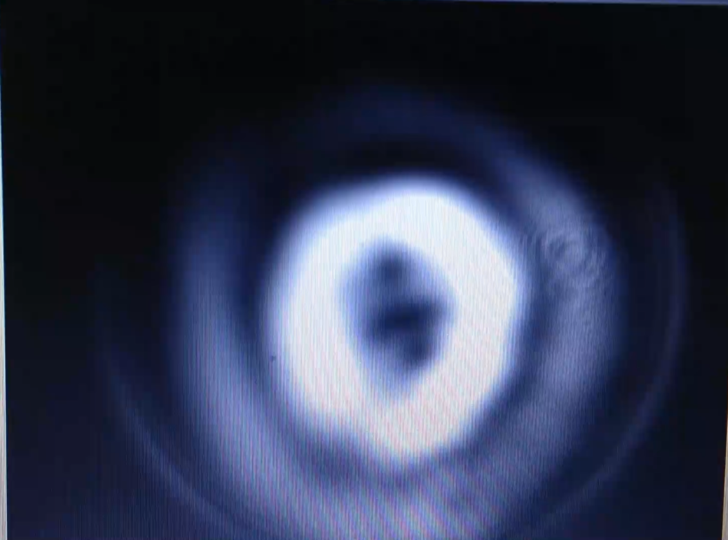

Fig. S6 Beam displacement after beam reduction of $l=-3$. (Video 1, MP4, 4760 KB)



Fig. S7 Gif figure of recorded 200 intensity profiles at the interval of 1 second for $l=+3$.



Fig. S8 Gif figure of recorded 200 intensity profiles at the interval of 1 second for $l=-3$.

# 8 50% probability distribution range

In this paper, there are many figures and results represent a statistic value because of the time-varying atmospheric turbulence. For all these figures, we calculate the probability distribution functions (PDF) which are Gaussian-like and depict them in red curves at the right of them. Here we define 50% probability distribution range as the range between the two values which is equal to half of the PDF’s maximum value. It means the power distribution mainly concentrate on this range and the narrower it is, the more stable the power distribute.